This media release is embargoed until 30 October 2024, 10 a.m. CET
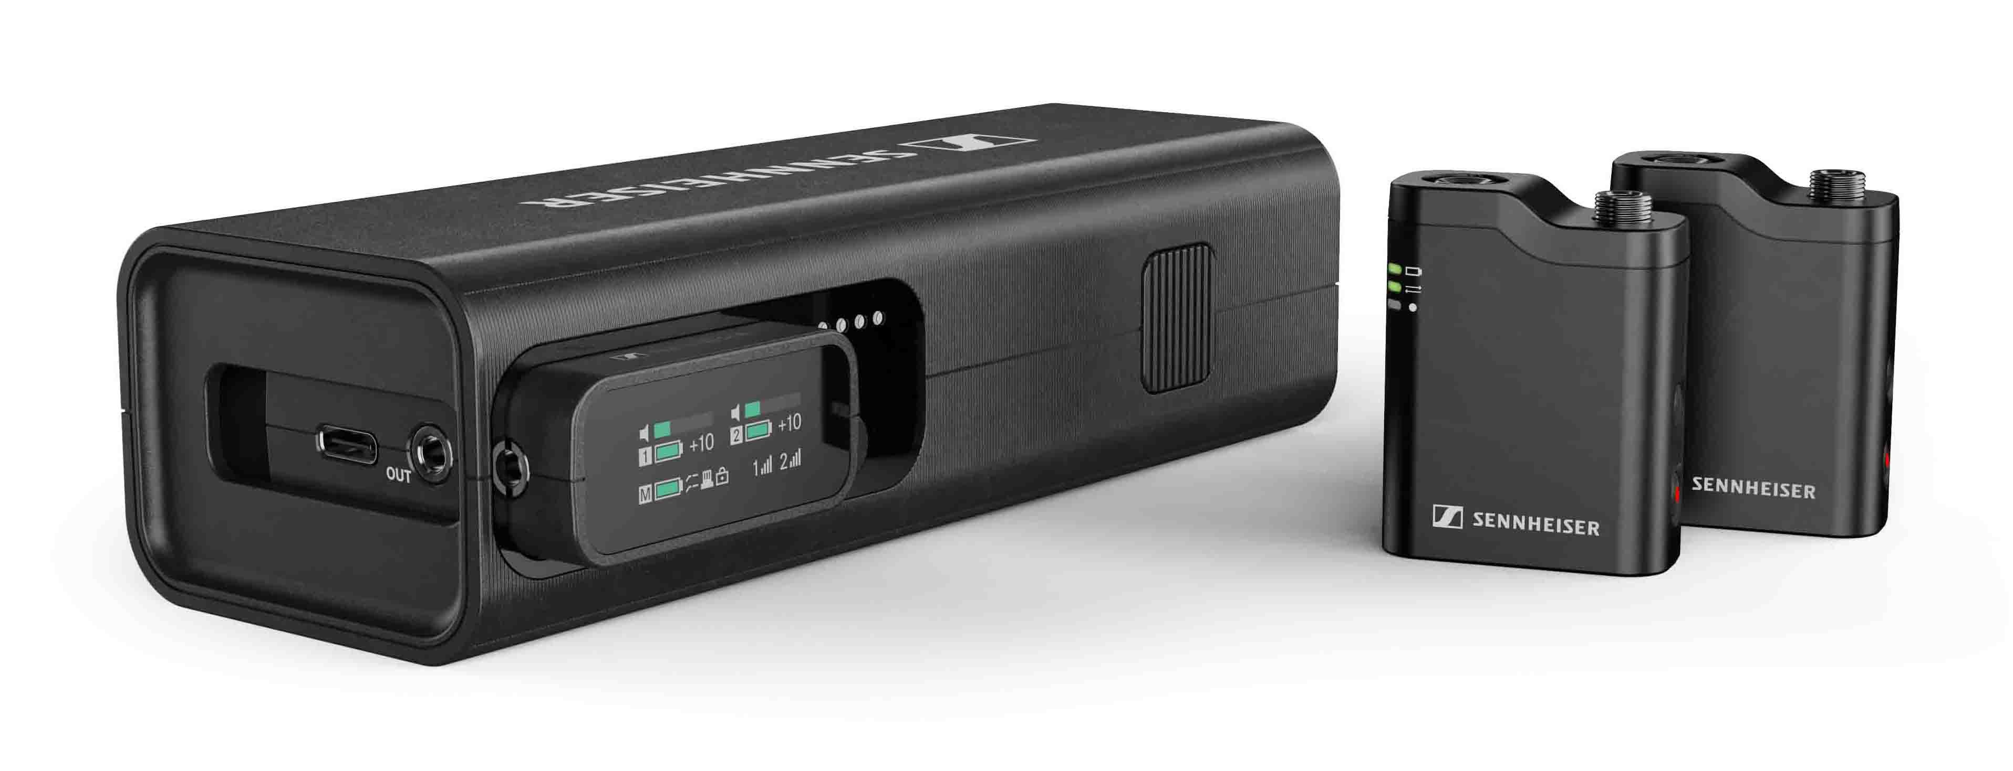
Sennheiser lancerer det perfekte multiværktøj til lydoptagelse for content creators
Profile Wireless, et 2-kanals, 2,4 GHz alt-i-en mikrofonsystem, giver videografer og content creators alt, hvad de behøver for at optage lyd i høj kvalitet ubesværet.
Wedemark, 30. oktober 2024 – Forberedelse og fleksibilitet er afgørende, når man skaber indhold, sammen med et alsidigt trådløst lydsystem, der hjælper med at optage lyd nemt og hurtigt uden at gå på kompromis med lydkvaliteten. Derfor introducerer Sennheiser nu Profile Wireless til content creators og videografer, som er et to-kanals, 2,4 GHz trådløst mikrofonsystem, der kan tilsluttes
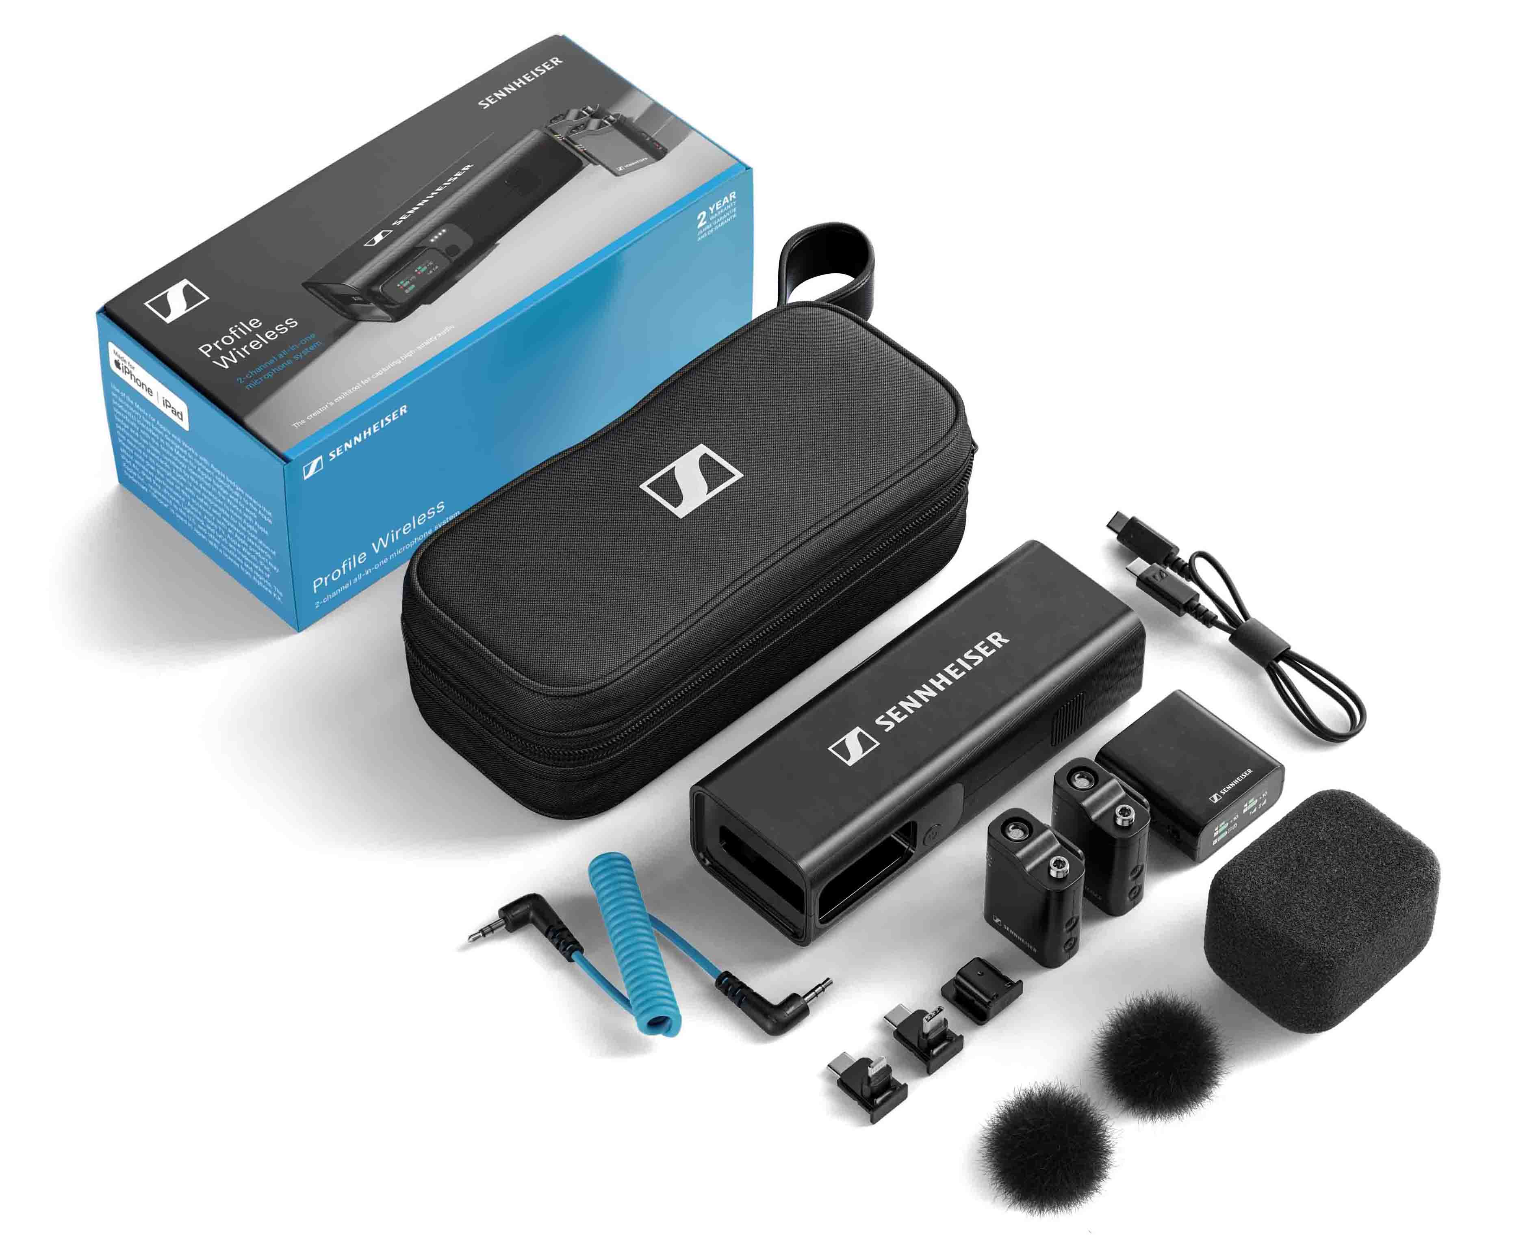 | Everything included for capturing high-quality audio with unprecedented ease of use

“We cannot imagine content creation today without compact 2.4 GHz mic systems, and I am really proud that Sennheiser is adding an all-in-one microphone system to its portfolio that truly makes a difference for creators and videographers,” says Hendrik Millauer, Product Manager, Broadcast and Film, at Sennheiser. “We’ve outfitted Profile Wireless with many exciting features that will help users to capture audio more reliably, longer, and more flexibly than was possible before.”

Open the zipper bag…
…and you hold a rugged, multifunctional charging bar in your hands. This charging bar is the heart of Profile Wireless. It stores and charges the key components of the system and doubles as a handheld or desktop mic. The charging bar safely holds a two-channel mini-receiver with an OLED touch display, two pre-paired clip-on microphones that automatically connect to the receiver, magnetic clips for attaching the mics to delicate clothing, and adaptors for connecting the receiver to mobile phones or a camera cold shoe mount. The bag also contains a 3.5 mm jack coiled cable for camera use, a USB-C to USB-C charging cable and windshields for the clip-on mics and charging bar.

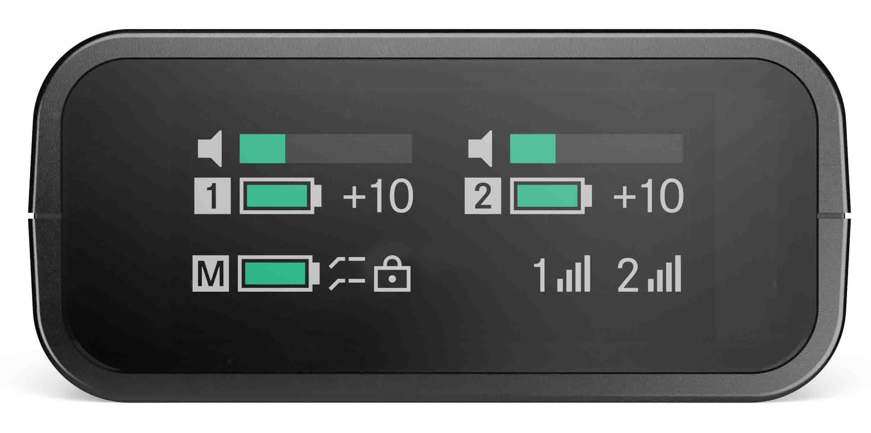 | As small as the two-channel receiver of Profile Wireless is, it offers clearly legible read-offs for both audio channels

A true audio multitool – versatile in every recording situation
“It was important to us that Profile Wireless can master a diverse set of recording requirements, while being as compact and portable as possible,” says Callie Blake, Category Marketing Manager, Creators. “The range of use cases for Profile Wireless is impressive.”

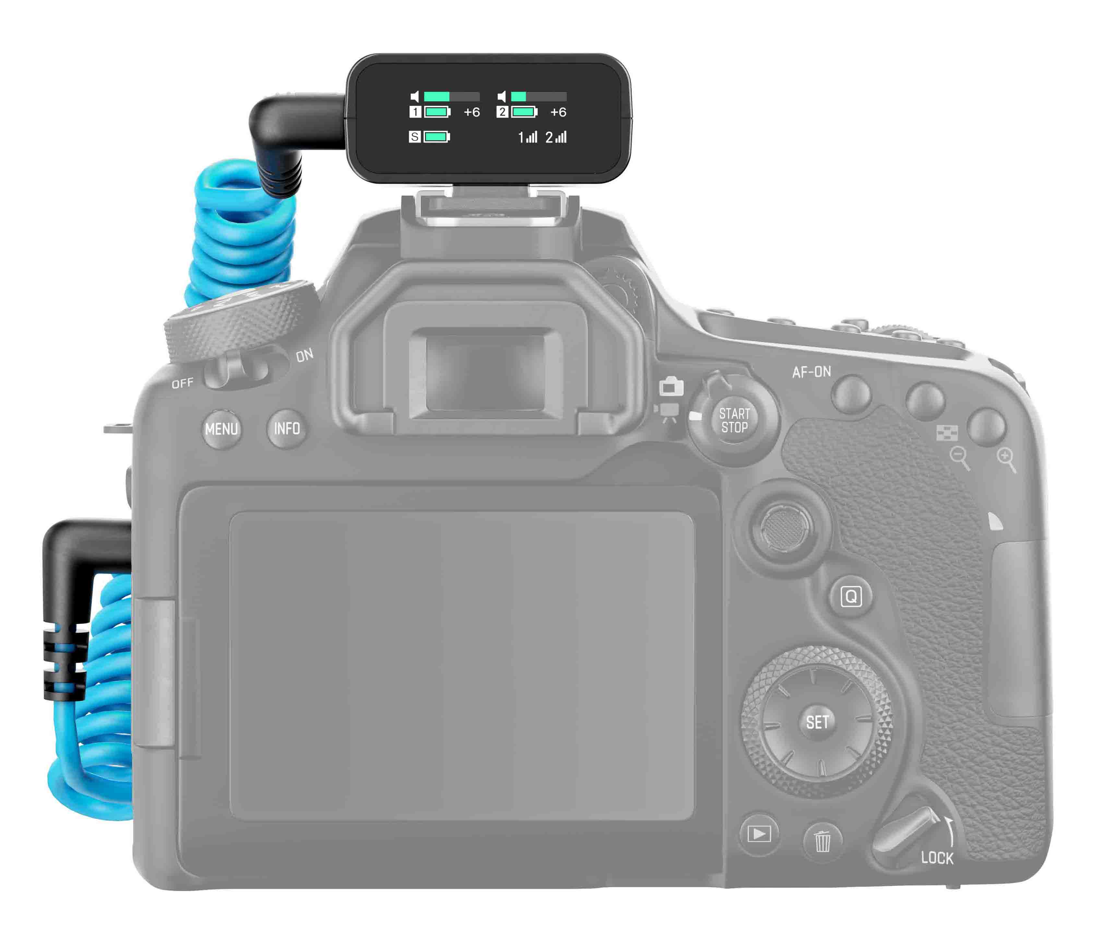
Profile Wireless used on camera in an interview scenario

With the included adaptors, the receiver connects to the filming device of choice, and lets the creator monitor the audio via a dedicated headphone output. The mini-mics of the system simply clip to the clothing or can be attached using the included magnetic mounts.

“While the clip-on mics ensure signature Sennheiser audio quality and are quite unobtrusive, there may still be instances where a creator or videographer would like to work with separate lavalier mics, so there’s a lockable 3.5 mm TRS jack for connecting external mics,” adds Blake.

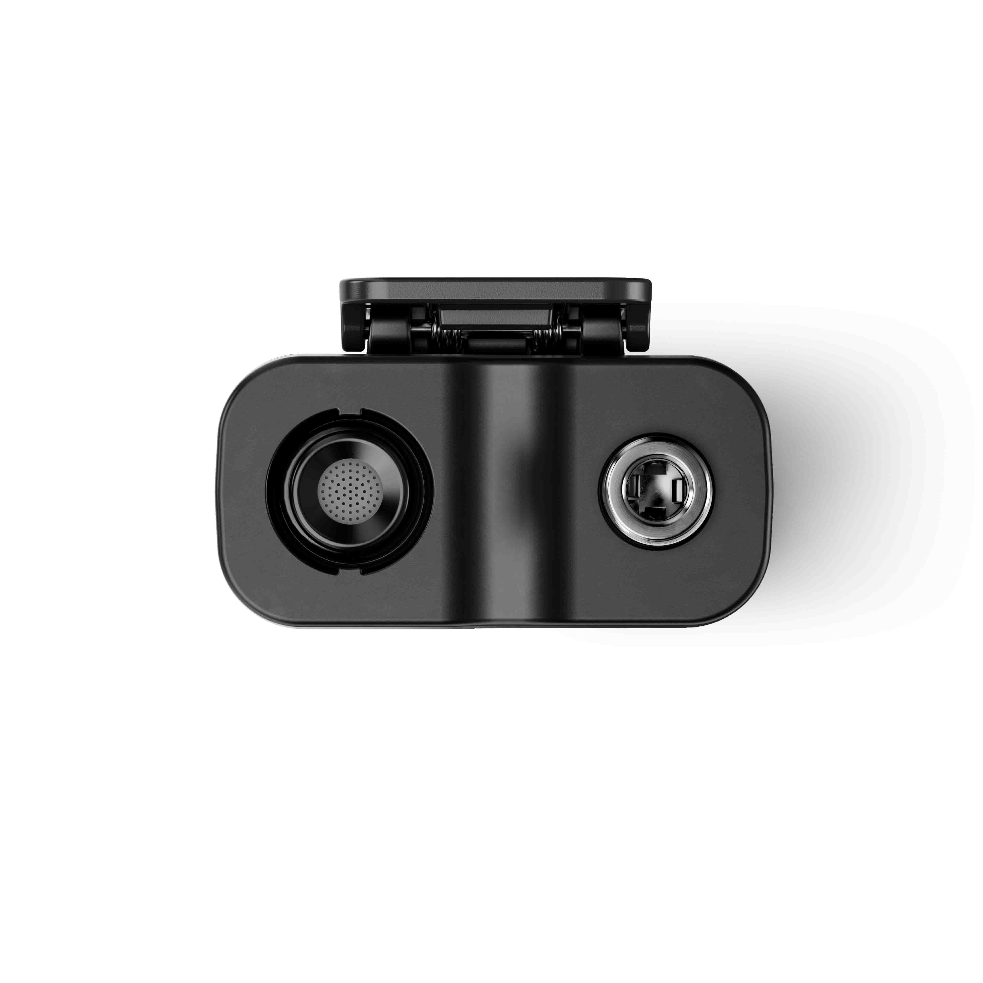
The clip-on mics of Profile Wireless feature an additional 3.5 mm (1/4”) connector for an external lav mic

When a mobile phone is used for capturing video, the Profile Wireless receiver is connected with the included Lightning or mini-USB adaptor. Thanks to a gyro-sensor, the receiver display automatically rotates by 180° to remain clearly legible.

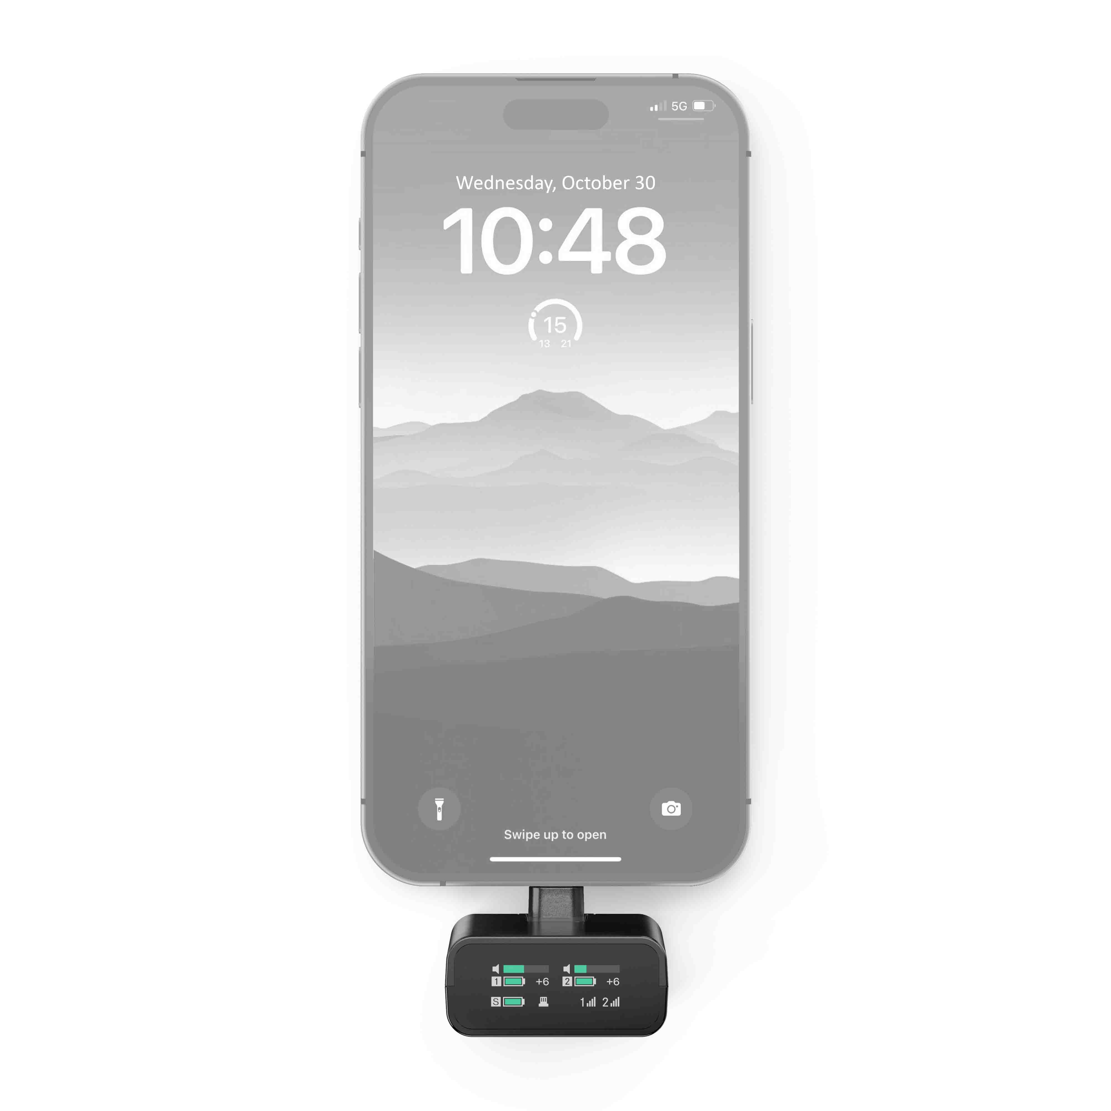
Profile Wireless used with a mobile phone to shoot vertical content

Handheld mic included
There are recording situations where a handheld microphone is an ideal choice, for example for reporter-style pieces to camera, and interviews where the creator needs more control over the conversation or is speaking with varying interviewees. For this application, the creator simply inserts a clip-on mic into the charging bar, puts the included big foam windshield on – and a fully-fledged reporter’s microphone is ready for the job.

Some situations require a handheld microphone – with Profile Wireless, there is one on board

All Profile Wireless components come with mounting threads for standard creator’s accessories such as table stands. Thus, the system can also be conveniently used as a desktop mic.

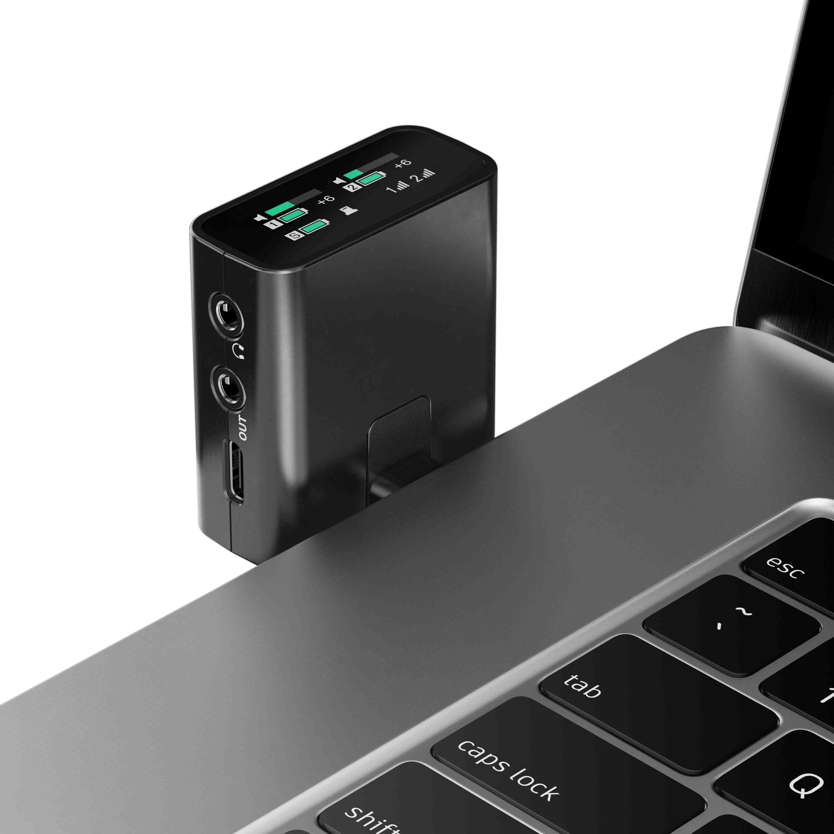
Profile Wireless used as a desktop mic, recording audio to a laptop

Reliability where you most need it
Losing audio on a shoot is a nightmare. Three clever functions in Profile Wireless help users get great audio even in difficult conditions. First and foremost, each clip-on microphone has 16 GB memory for internal recording – a comfortable safety net. When the creator activates Backup Recording Mode, internal recording will be automatically turned on if the wireless signal should become too weak. And finally, a Safety Channel Mode outputs and records backup audio at a lower volume to help protect against clipping.

“The clip-on microphone has 24-bit recording capability, and records simultaneously at two different audio levels”, notes Blake. “This not only reduces the risk of clipped audio, but also maximises the usable dynamic range of the capsule.”

Range is ample, at up to 245 m in line of sight, and up to 150 m line of sight when taking body blocking into account.

Why Profile Wireless is better
“Right from the start of product development, we involved seasoned videographers and content creators to see what they wished for from a compact wireless audio system, and how existing products could be improved upon,” shares Millauer. “So we’ve come up with a few exciting usability features that make Profile Wireless a gem among 2.4 GHz systems.

“Profile Wireless is the first and at present only compact 2.4 GHz wireless system that has a handheld option integrated, and this option gives you a real 15+ hours of runtime, while with other sets, you cannot use the mics when the system is being recharged,” Millauer continues.

“Usability features like the auto-rotating receiver display, the fact that no app is required, and the diverse mounting options – only Sennheiser has thread mounts on the components – make for smooth workflows in content creation. And while there may be lighter clip-on mics on the market, they do not have internal recording or a connector for an external lav mic.”

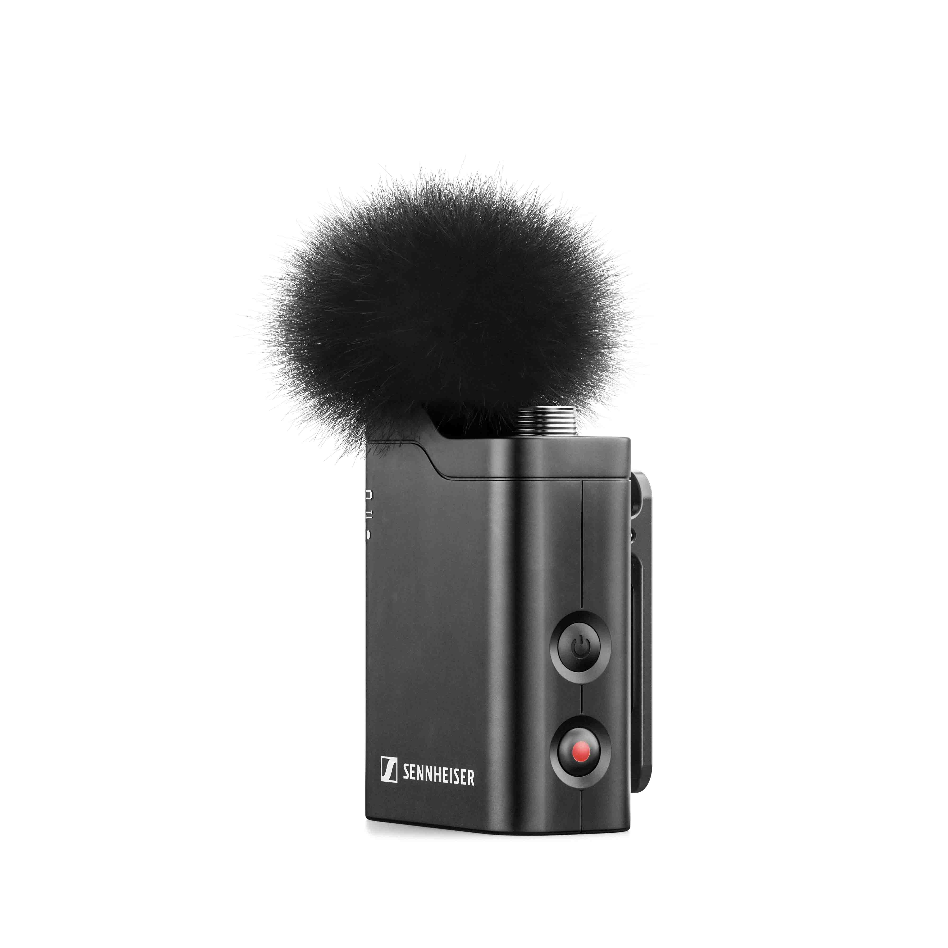 | The feature-packed clip-on microphone of Profile Wireless is fitted with a thread mount for creator accessories, a connector for an external lavalier microphone, and 16 GB of internal recording memory

Availability and pricing
Profile Wireless can be pre-ordered from 30 October and will start shipping in Q4/2024 and Q1/2025. The system retails at EUR 299 (MSRP), USD 299 (MAP), GBP 259 (MSRP).

(Ends)

Additional information for the editor
High-resolution Profile Wireless product pictures can be downloaded here.
High-resolution application photos can be downloaded here.

Specifications
System
RF link: 2400 – 2480 MHz
Audio frequency response: 60 – 20,000 Hz (110 – 20,000 Hz with low-cut filter activated)
Audio THD: < 1.5 %
Signal-to-noise ratio: typically 78.5 dB (A)
Transmission range (line of sight): ≤ 245 m
Transmission range (with body shielding): ≤ 150 m
System latency: < 8 ms
Operating temperature range: -10 to +45 C (32° F to 122° F)
Charging temperature range: 0 to +45 C (32° F to 122° F)
Operating humidity range (relative): 25 – 95 % (non-condensing)

Two-channel receiver
Transmission power: < 20 dBm EIRP
Camera output: min. 1 kΩ impedance
Digital output: USB-C audio class 2.0 / 48 kHz / 24 bit
Headphone output: 25 mW (min. 32 Ω impedance)
Operating time: ≤ 7 h
Charging time (0–100%): < 2 h
Battery capacity: 350 mAh / 1295 mWh
Dimensions: 45 x 42 x 19 mm
Weight: 30 g

Clip-on mic
Transducer principle: condenser
Pick-up pattern: omni-directional
Max. sound pressure level: 113 dB SPL
Transmission power: < 20 dBm EIRP
Operating time: ≤ 7 h (recording and transmitting) / ≤ 14 h (recording only)
Charging time (0–100%): < 1.5 h
Battery capacity: 280 mAh / 1036 mWh
Dimensions: 42 x 33 x 21 mm (including clip)
Weight: 27 g

Charging bar
Power supply: USB-C, charging current max. 1.5 A
Charging time (0–100%): < 3 h
Battery capacity: 2000 mAh / 7400 mWh
Dimensions: 152 x 41 x 55 mm
Weight: 198 g (empty) / 290 g (including all devices)

About the Sennheiser brand
We live and breathe audio. We are driven by the passion to create audio solutions that make a difference. Building the future of audio and bringing remarkable sound experiences to our customers – this is what the Sennheiser brand has represented for more than 75 years. While professional audio solutions such as microphones, meeting solutions, streaming technologies and monitoring systems are part of the business of Sennheiser electronic SE & Co. KG, the business with consumer devices such as headphones, soundbars and speech-enhanced hearables is operated by Sonova Holding AG under the license of Sennheiser.

www.sennheiser.com
www.sennheiser-hearing.com

Global Pro Audio Press Contact
Stephanie Schmidt
stephanie.schmidt@sennheiser.com
+49 (5130) 600 – 1275

